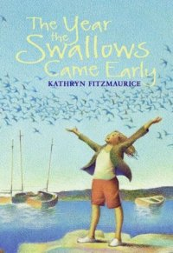

Kids Book Club Kit | Darien Library

The Year the Swallows Came Early by Kathryn Fitzmaurice
Recommended for grades 4 to 6

SUMMARY
The morning eleven-year-old Eleanor “Groovy” Robinson’s mother told Groovy her horoscope for the day was “expect the unexpected ” (p. 2) Groovy’s world came crashing down as her horoscope came true. Soon, Groovy would witness her father being arrested and her best friend Frankie coming in contact with the mother who abandoned him. While Groovy realizes that her dream to go to culinary school may be jeopardized and her family may never be one gain, she feels hope when she witnesses the swallows, which return to her town annually, return early.
Discussion starters
Groovy’s father calls her “Groovy” because of the way she danced as a baby. Do your parents or friends have a nick name for you? If so, why did they give it to you?
Discussion questions
- Groovy dreams of becoming a cook, and she plans on going to culinary school when she grows up. What do you want to be when you grow up? What do you think you will have to do to get there?
- Groovy’s great- grandmother leaves her a book called Foundation, which was her great- grandmother’s greatest treasure. Do you have any special treasures?
- Groovy is encouraged by Mr. Tom to forgive her father. Has there ever been a time when your parent/ sibling/ friend has done something wrong and you forgave him/ her?
- Frankie’s mother left him in America because she wanted him to get a good education. Has there ever been a time when your parent has made you do something you do not like to do for your own good? (like eating vegetables?)

Further Resources
Want to make chocolate-covered strawberries like Groovy? Check out this recipe!
http://www.bettycrocker.com/recipes/white-chocolate-dipped-strawberries

Activities
Groovy made specific foods after certain things happened. Create a menu by writing what food should be made for each occurrence:
(Breakfast) First day of school:
(Snack) After losing a soccer game:
(Lunch) Big test day!:
(Dinner) After having a bad day:
(Snack made for a parent): Before asking a parent for something you really want:

